<https://us1.ca.analytics.ibm.com/bi/?perspective=explore&pathRef=.my_folders%2FNew%2Bexploration%2B-%2Bbar%2Blength%2Bcolor&subView=model000001836497f261_00000000>

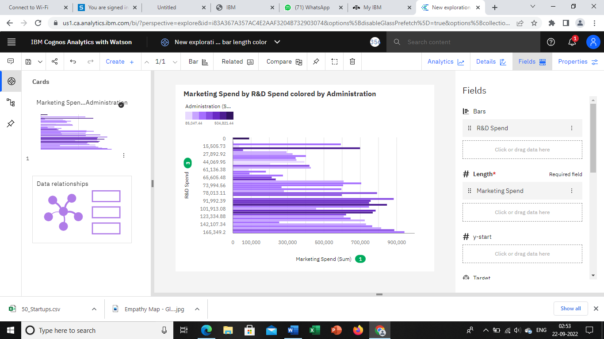

<https://us1.ca.analytics.ibm.com/bi/?perspective=explore&pathRef=.my_folders%2FNew%2Bexploration%2B-%2Bbar%2Blength%2Bcolor&subView=model00000183649e68c6_00000000>

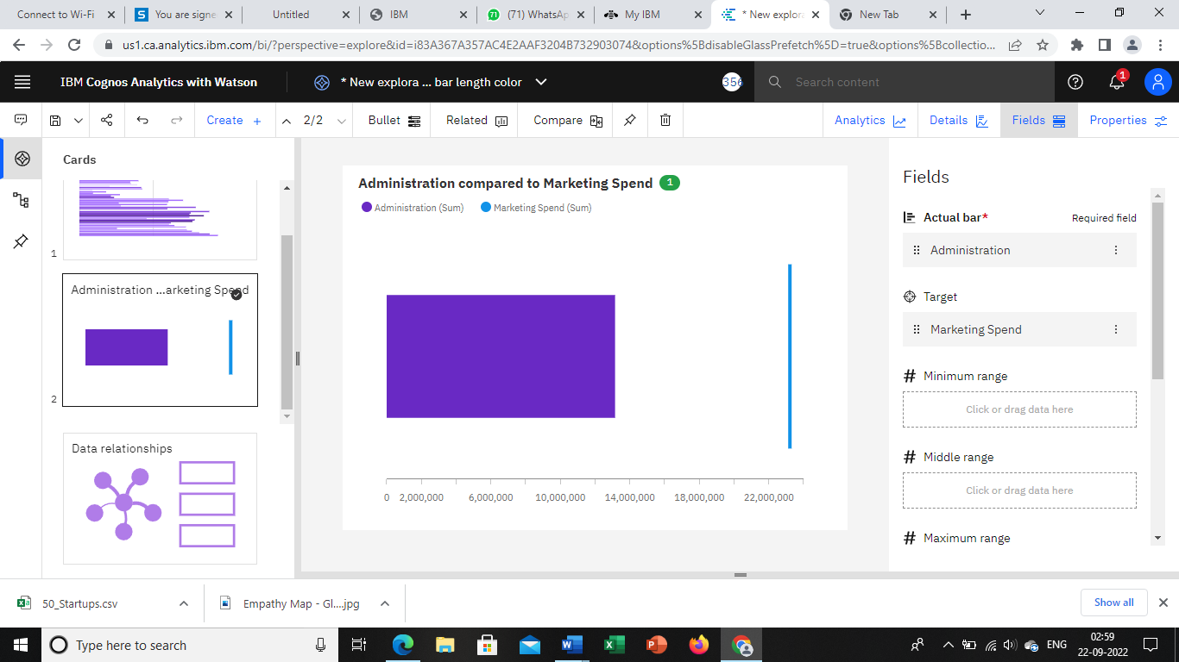

<https://us1.ca.analytics.ibm.com/bi/?perspective=explore&pathRef=.my_folders%2FNew%2Bexploration%2B3&subView=model0000018364a4ac58_00000000>

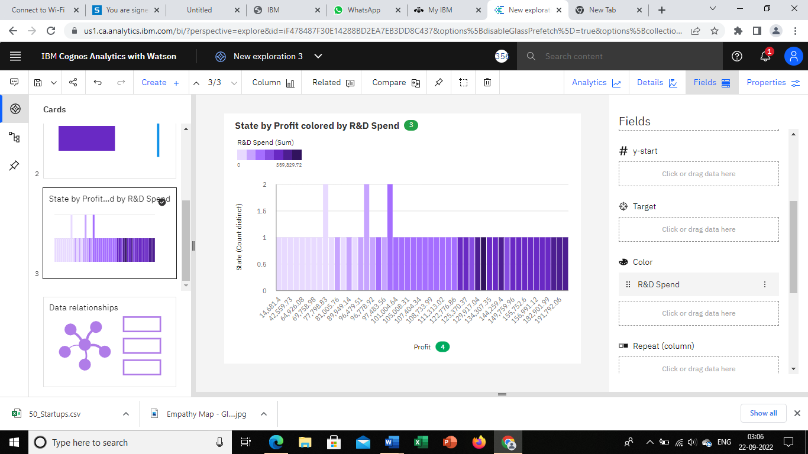

<https://us1.ca.analytics.ibm.com/bi/?perspective=explore&pathRef=.my_folders%2FNew%2Bexploration%2B4&subView=model0000018364aa1b8c_00000000>

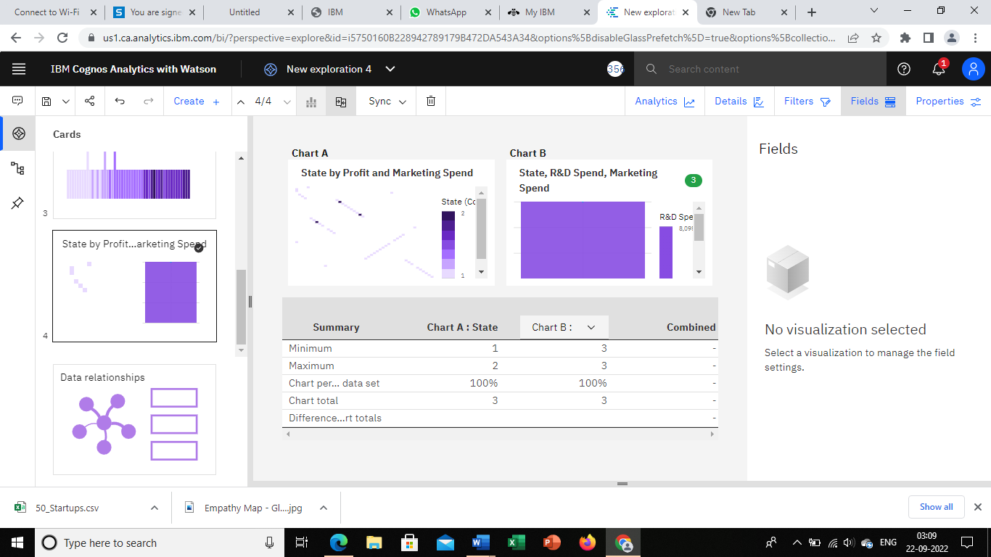

<https://us1.ca.analytics.ibm.com/bi/?perspective=explore&pathRef=.my_folders%2FNew%2Bexploration%2B5&subView=model0000018364acd645_00000004>

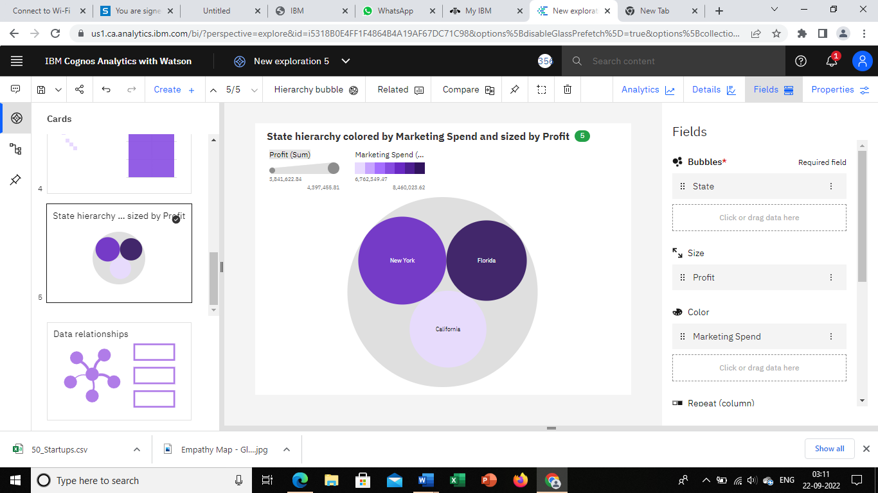

<https://us1.ca.analytics.ibm.com/bi/?perspective=explore&pathRef=.my_folders%2FNew%2Bexploration%2B6&subView=model0000018364aed89c_00000004>

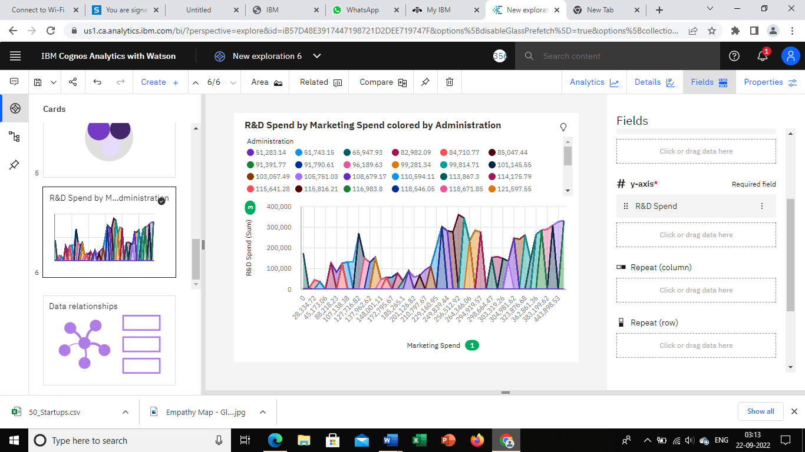

<https://us1.ca.analytics.ibm.com/bi/?perspective=explore&pathRef=.my_folders%2FNew%2Bexploration%2B7&subView=model0000018364b05548_00000002>

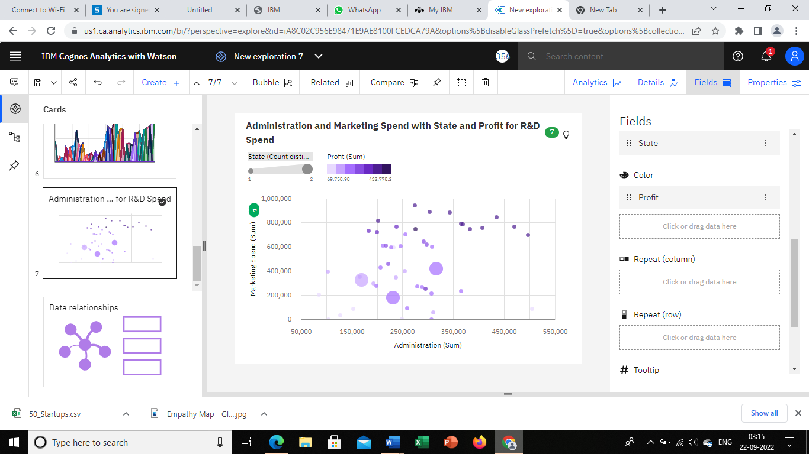

<https://us1.ca.analytics.ibm.com/bi/?perspective=explore&pathRef=.my_folders%2FNew%2Bexploration%2B8&subView=model0000018364b2b489_00000000>

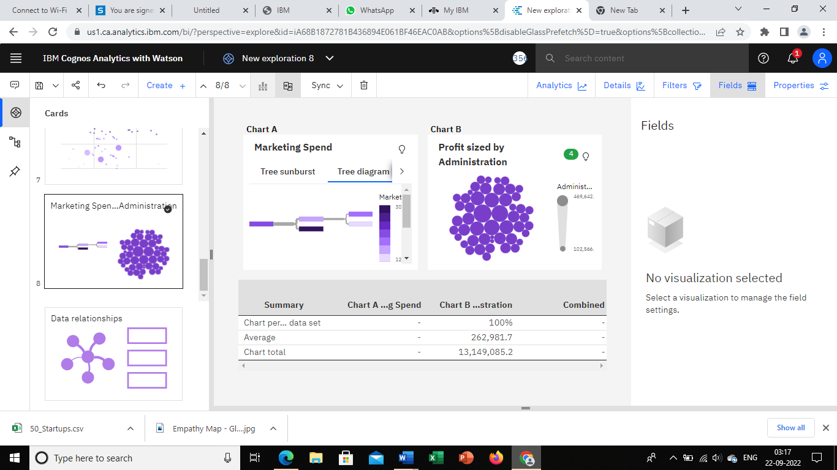

<https://us1.ca.analytics.ibm.com/bi/?perspective=explore&pathRef=.my_folders%2FNew%2Bexploration%2B9&subView=model0000018364b47125_00000002>

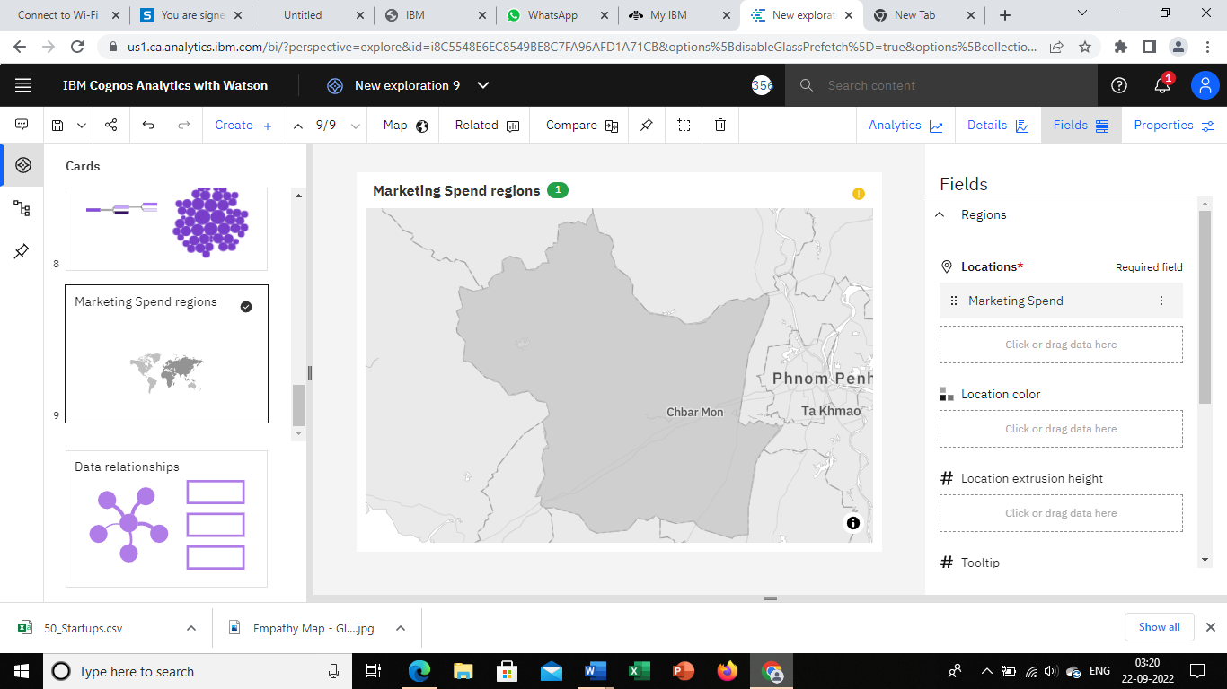

<https://us1.ca.analytics.ibm.com/bi/?perspective=explore&pathRef=.my_folders%2FNew%2Bexploration%2B10&subView=model0000018364b72ada_00000004>

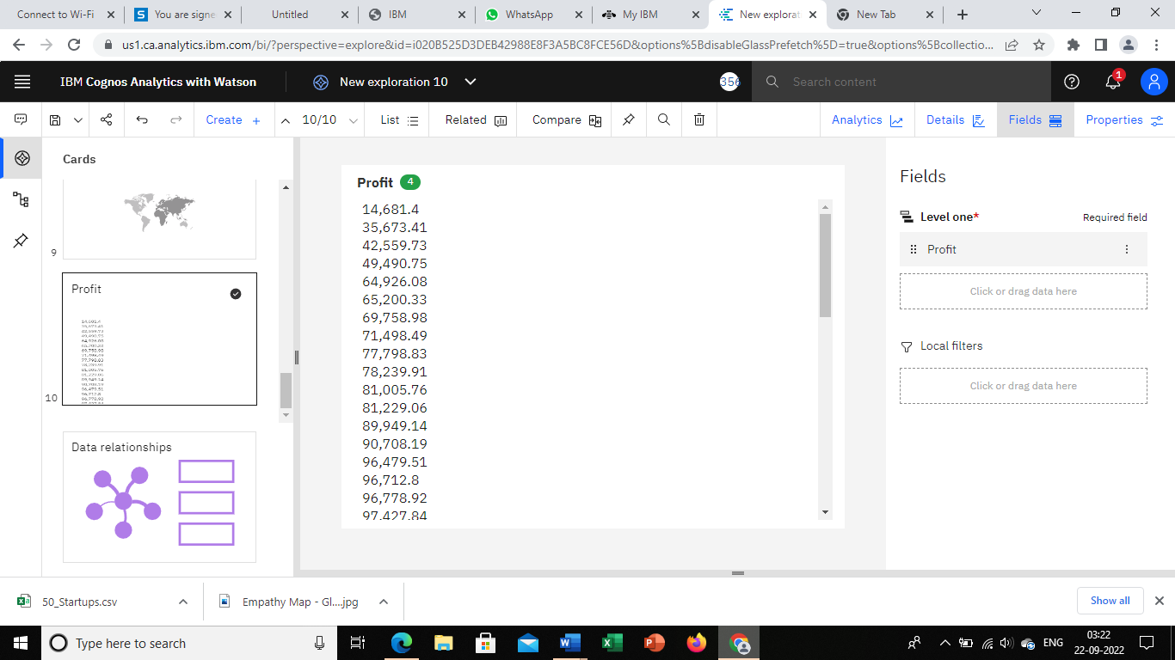

<https://us1.ca.analytics.ibm.com/bi/?perspective=explore&pathRef=.my_folders%2FNew%2Bexploration%2B11&subView=model0000018364b8c724_00000003>

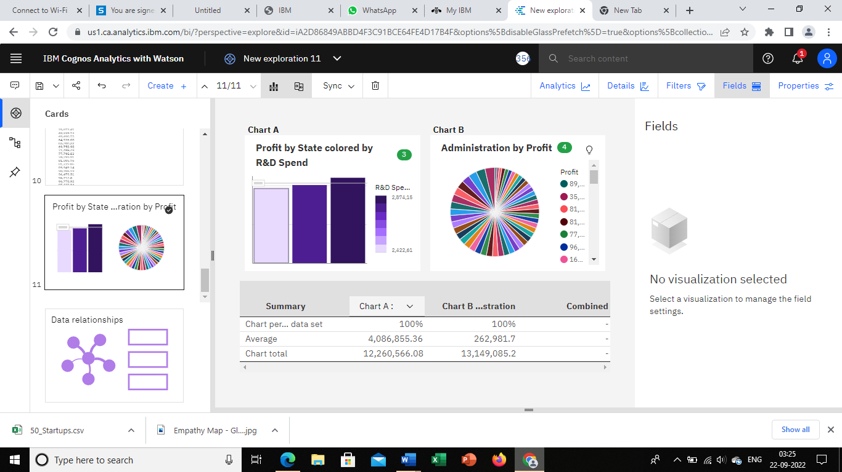

<https://us1.ca.analytics.ibm.com/bi/?perspective=explore&pathRef=.my_folders%2FNew%2Bexploration%2B12&subView=model0000018364bb3912_00000004>

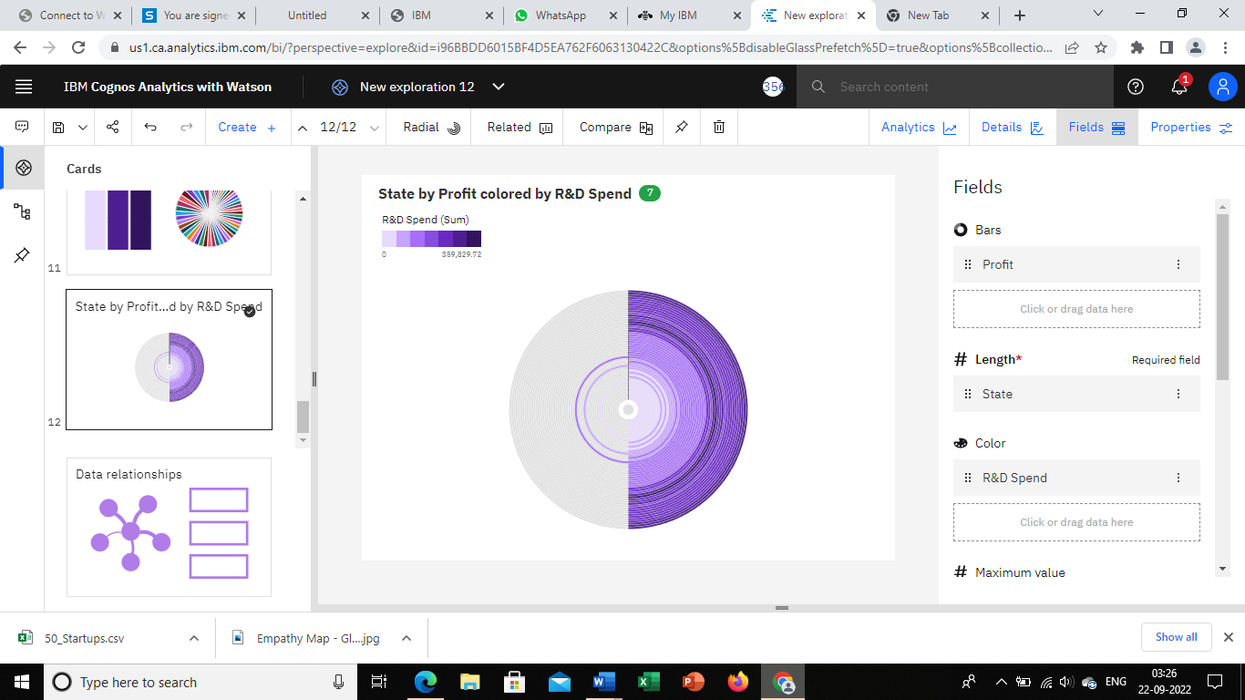

<https://us1.ca.analytics.ibm.com/bi/?perspective=explore&pathRef=.my_folders%2FNew%2Bexploration%2B13&subView=model0000018364bc9ca7_00000000>

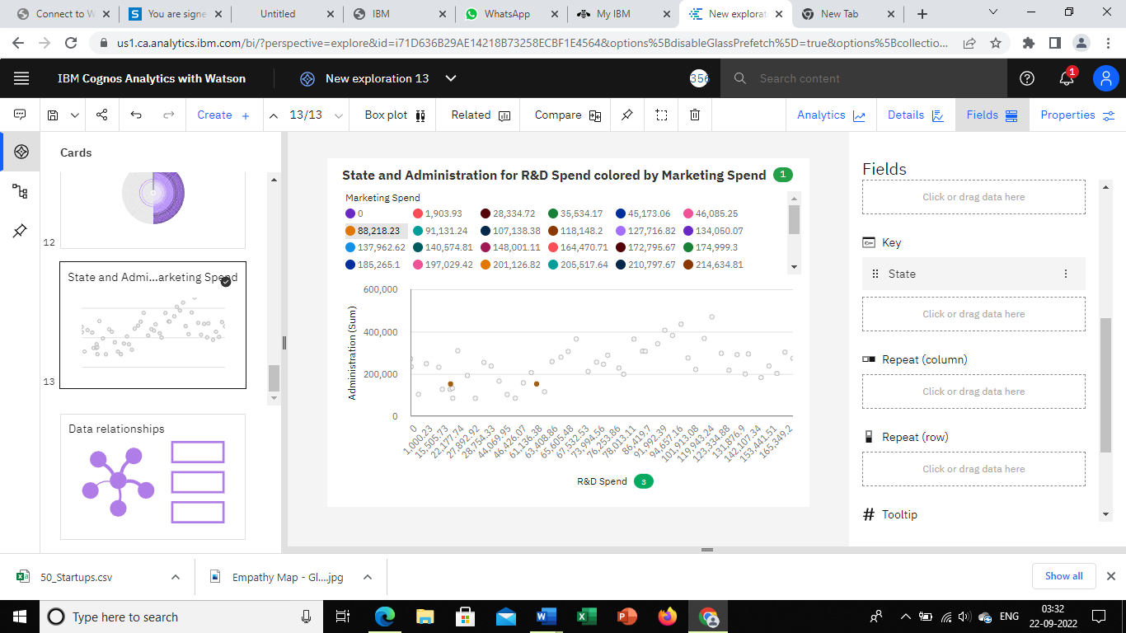

<https://us1.ca.analytics.ibm.com/bi/?perspective=explore&pathRef=.my_folders%2FNew%2Bexploration%2B14&subView=model0000018364c20dd2_00000004>

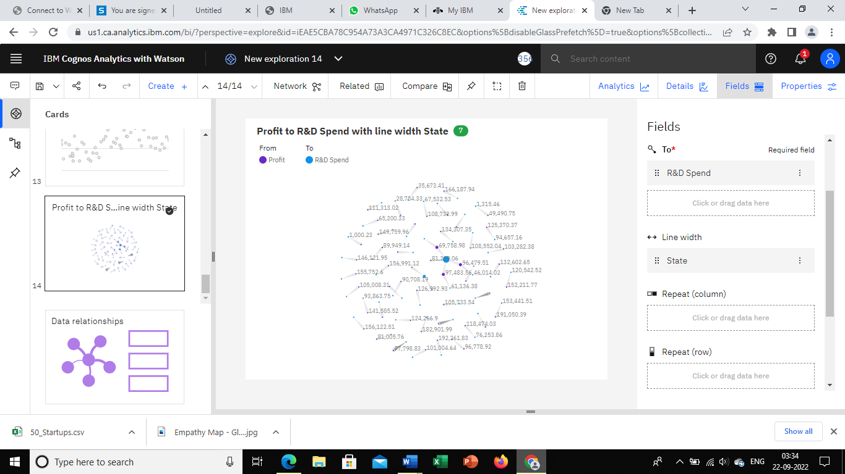

<https://us1.ca.analytics.ibm.com/bi/?perspective=explore&pathRef=.my_folders%2FNew%2Bexploration%2B15&subView=model0000018364c376d2_00000000>

